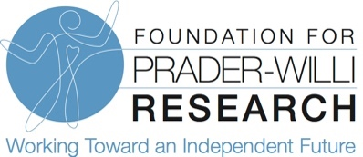

Dear Friends,
Our loved ones with PWS face a multitude of challenges every day, but we’re not just waiting and hoping for new treatments and a cure for Prader-Willi syndrome, we are aggressively doing something about it. Our loved ones want to have FULL and independent lives and it is up to us to make sure that becomes a reality. That is why we are asking you to join us, so we can help every single family overcome the challenges of PWS. With your help, I have no doubt we will find treatments that will help our loved ones with PWS, lead FULL and independent lives.
We have made tremendous progress but until treatments are found, we cannot slow our efforts. Support from our PWS community has allowed us to grow our drug development pipeline. More than one dozen drugs are now in various stages of development. Our team dedicates hundreds of hours each year to supporting drug development and we need your continued support so that we may aid in clinical trial design and work to develop trials that have the best chances for success.

On average it takes 12 years to bring a new drug to market, but people with PWS and their families need treatments NOW! FPWR’s clinical care research program aims to find near-term solutions that will alleviate the symptoms of PWS and improve quality of life. FPWR dedicates funds each year supporting projects that will improve the treatment of behavioral, scoliosis, seizures, and GI motility, mental health and more.

We know genetic therapy is promising, but there is much we still need to learn in order to advance this technology into clinical trials. Can you imagine an independent life for our loved ones with PWS? We can. A successful genetic therapy approach could simultaneously improve many aspects of PWS, but much still needs to be learned, and tested, to determine what benefits this approach will have for individuals with PWS.

Failure is not an option. We know the challenges our loved ones will continue to face if we do not find treatments for PWS. For many of us who live with PWS every day, the status quo is simply not an option. Our loved ones with PWS are relying on us. This is why we pour our blood, sweat, and tears into raising funds for research: it’s our only path to a better future. Our donor network of family and friends are imperative to our success and we thank you for your continued support!

Treatments for PWS are possible and with your help, we can find them faster. We look forward to the day when our loved ones can lead the FULL and independent lives they deserve! Thank you for your commitment to PWS research.

Sincerely,

Susan Hedstrom
Executive Director, FPWR

