Dr. Deniz Atasoy
Department of Neuroscience and Pharmacology
University of Iowa, 2-432 BSB,
51 Newton Rd., Iowa City, IA 52242

Dr. Anne Bang
Sanford Burnham Prebys Medical Discovery Institute,
10901 North Torrey Pines Road,
La Jolla, CA 92037

Dr. Haijiang Cai
Department of Neuroscience
University of Arizona
GS 611, 1040 E. 4th St. PO Box 210077
Tucson, AZ 85721-0077

Dr. Lei Cao
The Ohio State University Comprehensive Cancer Center
460 W 12th Ave, Columbus, OH 43210

Dr. Gordon Carmichael
Genetics and Genomic Sciences
University of Connecticut Health
263 Farmington Avenue
Farmington, CT 06030-3301

Dr. Marcelo Dietrich
Brady Memorial Laboratory
Yale University
310 Cedar Street, Ste 330C, New Haven, CT, 06510

Dr. Edward Fox
Department of Psychological Sciences
Purdue University
703 Third Street
West Lafayette, IN 47907-2081 USA

Dr. Nahid Iglesias
Box 90281
CIEMAS Rm. 1427
101 Science Drive
Duke University
Department of Biomedical Engineering
Durham, NC 27708

Dr. Young-Hwan Jo
Albert Einstein College of Medicine
1300 Morris Park Avenue, Forchheimer Building, Room 505A, Bronx, NY 10461

Dr. Amnon Koren
Cornell University
349 Biotechnology Bldg
526 Campus Rd, Ithaca, NY 14850

Dr. Malcolm Low
Department of Molecular & Integrative Physiology
University of Michigan Medical School
6116 Brehm Tower
1000 Wall St. Ann Arbor, MI 48105

Dr. Rob Nicholls
University of Pittsburgh, Department of Pediatrics
4401 Penn Avenue, Pittsburgh, PA 15224

Dr. Larry Reiter
University of Tennessee Health Sciences Center
855 Monroe Avenue, Suite 415, Memphis, TN 38163

Dr. Jim Resnick
University of Florida, Department of Molecular Genetics and Microbiology
1200 Newell Drive, Gainesville, FL, 32610-0266

Dr. Deepan Singh
Maimonides Medical Center
920 48th Street, Brooklyn, New York 11219

Dr. Derek Tai
Center for Genomic Medicine
Massachusetts General Hospital
185 Cambridge Street, Boston, MA 02114

Dr. Michael Talkowski
Center for Genomic Medicine
Massachusetts General Hospital
185 Cambridge Street, Boston, MA 02114

Dr. Hui Yu
Department of Molecular & Integrative Physiology
University of Michigan Medical School
6434 Brehm Tower
1000 Wall St. Ann Arbor, MI 48105

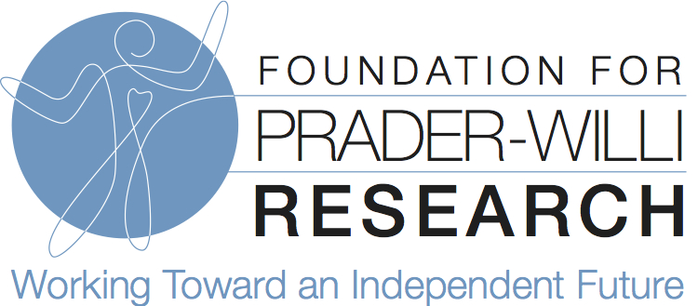

Dr. Marnie Blewitt
blewitt@wehi.edu.au

Drs. Sebastien Bouret & Francoise Muscatelli
sebastien.bouret@inserm.fr
francoise.muscatelli@inserm.fr

Dr. Claudio Mussolino
claudio.mussolino@uniklinik-freiburg.de

Dr. Louise Gallagher
lgallagh@tcd.ie

Dr. David Godler
david.godler@mcri.edu.au

Dr. Pawel Grzechnik
P.L.Grzechnik@bham.ac.uk

Dr. Tony Holland
Ajh1008@medschl.cam.ac.uk

Dr. Anthony Isles
IslesAR1@cardiff.ac.uk

Dr. Lauren Rice
Lauren.rice@sydney.edu.au

Dr. Christian Schaaf
Christian.Schaaf@med.uni-heidelberg.de

Dr. Nora Shields
N.Shields@latrobe.edu.au

Dr. Timothy Wells
Wellst@cardiff.ac.ak

Dr. Rachel Wevrick
rwevrick@ualberta.ca

