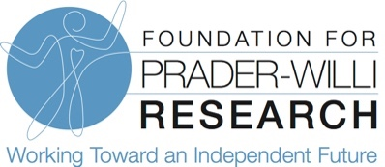

Dear Friends,

While our country is on the rebound from Covid-19 and life is beginning to look a lot more normal, the impact of the pandemic on PWS research has been significant and we need your support to continue advancing PWS research initiatives this year. As a result of the pandemic, FPWR experienced a nearly $2 million dollar shortfall, forced us to reduce staffing, and kept researchers out of their labs. With restrictions lowered, and our researchers back in the lab, now is the time to step on the accelerator and press research forward. We have a lot of work to do in order to fulfill our mission and find treatments for PWS. This is why we need your dollars:

We have made tremendous progress but until treatments are found, we cannot slow our efforts. In the past 5 years, your financial support has allowed us to grow our drug development pipeline. More than one dozen drugs are now in various stages of development and 2 have completed phase 3 clinical trials with positive results. Our team dedicates hundreds of hours each year to supporting drug development and we need your continued support so that we may aid in clinical trial design and work to develop trials that have the best chances for success.

On average it takes 12 years to bring a new drug to market, but people with PWS and their families need treatments NOW! FPWR’s clinical care research program aims to find near-term solutions that will alleviate the symptoms of PWS and improve quality of life. FPWR dedicates funds each year supporting projects that will improve the treatment of behavioral, scoliosis, seizures, and GI motility, mental health and more.

We know genetic therapy is promising, but there is much we still need to learn in order to advance this technology into clinical trials. Can you imagine an independent life for our loved ones with PWS? We can. A successful genetic therapy approach could simultaneously improve many aspects of PWS, but much still needs to be learned, and tested, to determine what benefits this approach will have for individuals with PWS.

Failure is not an option. We know the challenges our loved ones will continue to face if we do not find treatments for PWS. For many of us who live with PWS every day, the status quo is simply not an option. Our loved ones with PWS are relying on us. This is why we pour our blood, sweat, and tears into raising funds for research: it’s our only path to a better future. Our donor network of family and friends are imperative to our success and we thank you for your continued support!

Treatments for PWS are possible! Only two things stand in our way: time and funding. But funding can buy time and accelerate our work towards treatments for PWS and that is something we can all contribute towards! We thank you for your commitment to PWS research and look forward to the day when our loved ones can lead the FULL and independent lives they deserve!

Sincerely,

Susan Hedstrom
Executive Director, FPWR
Mom to Jayden, age 12 with PWS

