Dear Supporter,

On May 20th 2017, we are hosting the 1st Annual Savannah Strong Charity Golf Classic at Prairie Highlands Golf Course. All proceeds from the event will fund critical research for Prader-Willi Syndrome (PWS), a rare, non-inherited genetic disorder that Savannah and her friends are born with.

Prader-Willi syndrome (PWS) is a genetic disorder that occurs in approximately one out of every 12,000 births. Children with PWS suffer from feeding difficulties in infancy, delayed speech and physical milestones, short stature, scoliosis, sleep disturbances, behavioral challenges and cognitive delays. The defining symptom of PWS however, is hyperphagia, or, an insatiable appetite. Children with PWS feel hungry all the time, regardless of how much they eat. They also suffer from a slow metabolism and must keep on a very strict diet to avoid life threatening weight gain. Without continuous supervision, our children are constantly at risk for overeating to the point of stomach rupture.

Currently there are few treatments and no cure for Prader-Willi Syndrome.

As parents of a remarkable and inspiring child with PWS, we decided to be as proactive as possible in helping to fund research for this challenging disorder. We know that through medical research, we can help to eliminate the many hurdles that our child, and so many others, face on a daily basis.

Your participation is critical to our success and we would be thrilled if you would consider becoming a sponsor of our event. With sponsorship, you will gain marketing exposure for yourself or your business and have the potential to reach countless others based on your sponsorship level. Enclosed you will find accompanying documents, which list the various benefits based on the different sponsorship levels.

Thank you in advance for helping to make the 1st Annual Savannah Strong Charity Golf Classic a success and ensuring that Savannah, and all of those living with Prader-Willi Syndrome, will one day be able to live life FULL.
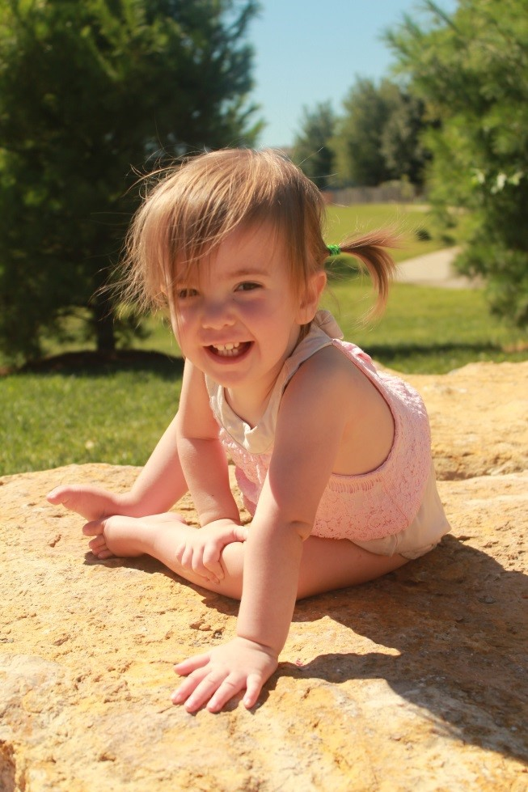

Sincerely,

The Bacon Family

The Foundation for Prader-Willi Research is recognized as a 501(c) (3) organization by the Internal Revenue Service (ID # 31-1763110).

Sponsorship Opportunities

Platinum Level Sponsorship----$1000.00 or greater
Your Platinum Level Sponsorship will include all of the following:
- Name on a poster "Thank you to our sponsors" listed by appropriate level
- Name on the back of the T-shirt
- Marketing materials included at event check-in/check out with option to have staff representative at designated hole.

Gold Level Sponsorship----$500.00
Your Gold Level Sponsorship will include the following:
- Name on poster “Thank you to our sponsors" listed by appropriate level
- Name on the back of the T-shirt
- Marketing Materials included at event check-in/check out

Silver Level Sponsorship----$350.00
Your Silver Level Sponsorship will include the following:
- Name on poster “Thank you to our sponsors" listed by appropriate level
- Name on the back of the T-shirt

Bronze Level Sponsorship----$250.00
Your Bronze Level sponsorship will include the following:
- Name on poster “Thank you to our sponsors" listed by appropriate level

Hole Sponsor (Limited)----$100.00
- Name of the company on a sign stating "this hole sponsored by _______".

SPONSORSHIP COMMITTEMENT FORM

Two convenient ways to sponsor:

Online via Credit Card: https://www.fpwr.org/events/savannahstrong2017/

Sponsorship via check:

Sponsorship Level: ________________________________________ Sponsorship Amount: _______________

Business Name: ________________________________________________________________

Street Address: (For Receipt)_______________________________________________________________________

City____________________________________________ State______________________ Zip___________________

Contact Name_________________________________________ Phone Number: ____________________________
Email: _______________________________________________________________________________

Please Make Checks Payable To FPWR and mail to:
FPWR
340 S. Lemon Ave, #3620
Walnut, CA 91789

The Foundation for Prader-Willi Research is recognized as a 501(c)(3) organization by the Internal Revenue Service (ID # 31-1763110).

